UNIVERSITY OF CENTRAL PUNJAB

(Faculty of IT)

**Computer Communications and Networks (CCN)**

**Assignment No Date :**

**Total Marks:**  **Due Date:** ___

1- In order to overcome the quickly depleting IPv4 address pool, NAT was proposed, which provides a fix for this problem. Consider that Host A with IP Address 10.0.0.1 and port number 2445, is behind a NAT router installed at a University Campus. NAT router has the global IP Address of 113.11.11.7. Host A communicates with the outside world Host B with IP Address 105.12.31.4 and port number 80.

Draw the network diagram showing various systems and the NAT table, and write down the ***source and destination IP* addresses, along with *source and destination* *port numbers***for the IP packet, as it travels from **source to router, from router to destination, from destination to router and from router to source again.** Assume suitable port numbers for address translation, where required.

2-Assume the following routing table in a router.

|  |  |
| --- | --- |
| Address/mask | Interface |
| 10.4.1.0/24 | 0 |
| 10.4.1.32/27 | 1 |
| 10.0.0.0/8 | 2 |
| Default | 3 |

What is the next hop/interface for IP 10.4.1.62,given that you use longest-prefix matching?

3-Assume the following routing table in a router.

|  |  |
| --- | --- |
| Address/mask | Interface |
| 192.168.2.80/29 | 0 |
| 192.168.2.64/27 | 1 |
| 192.168.2.0/24 | 2 |
| Default | 3 |

What is the next hop/interface for IP 192.168.2.82,given that you use longest-prefix matching?

Q4. Assume the following routing table in a router.

|  |  |
| --- | --- |
| Address/mask | Interface |
| 135.46.56.0/22 | 0 |
| 135.46.60.0/22 | 1 |
| 192.53.40.0/23 | 2 |
| Default | 3 |

What is the next hop for each of these addresses, given that you use longest-prefix matching?

a. 135.46.63.10

b. 135.46.57.14

c. 192.53.40.7192.53.56.7

5- Differentiate between Time Division Multiplexing and Frequency Division Multiplexing. Use appropriate diagrams for comparison.

6- Discuss the process of FLSM using examples from class A, B and C. For example, take 192.168.10.0/24 network and divide it into 8 subnetworks using FLSM. You are required to take 3 examples from each class and perform FLSM. For greater number of Subnets, let’s say 1000 subnets for class B, you can mention only 5 which would be enough to show that you have performed correct process.

**Note:** 3 examples for subnet requirements and 3 for host requirement, the requirement types are up to you.

7-Consider the following network diagram with the indicated link costs, use Dijkstra’s shortest-path algorithm to compute the shortest path from ‘a’ to all network nodes. Show all the working and how the algorithm works by computing a table. Also draw forwarding table. (Use Slides not the DSA subject process for solution)

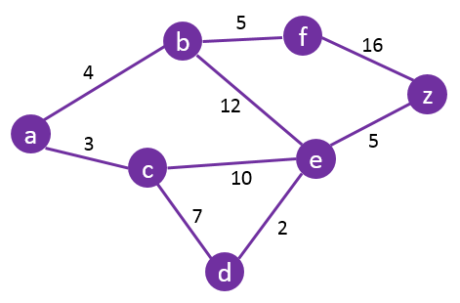

8- Discuss the applications of ICMP protocol.

9- Discuss the DORA process of DHCP with the help of diagram, for each step use a diagram show manipulation of IP’s as well do not use a generic picture taken from the internet. The DHCP client server scenario slides may be helpful in this question.

***Assignment Guidelines:***

*Assignment is to be done* ***individually****.*

***Assignment should be handwritten.***

*The answers should be in your* ***own words****; there should be* ***no copying*** *from any source.*

*The neatness of the assignment will also carry marks.*

*Assignments will* ***NOT be accepted after the due date.***

***Marking Criteria:****30% marks will be awarded for complete submission of assignment; 70% evaluation will be based on Assignment Test, to be conducted in class.*